# 

# 

**Control4 Driver Manual**

# Table of Contents

**Table of Contents** **1**

**1. Introduction** **2**

**2. Installation** **3**

2.1 Installation Order 3

2.2 Installing the Roon Core driver 3

2.3 Installing the Roon Zone driver 4

**3. Configuration** **5**

3.1 Roon Core driver configuration 5

3.2 Roon Zone driver configuration 7

3.3 Configure Zone Grouping 9

**4. Events Programming** **11**

4.1 Device Specific Commands in Roon Zone Driver 11

**5. Support** **12**

## 

## 

# 1. Introduction

The Roon Control4 drivers provide the following:

1. Browsing of Roon’s Library and Music Services from Control4
   * Library
   * TIDAL
   * Search
   * Playlists
   * Genre Browsing
2. Control of Roon’s zones from Control4
   * Transport controls
   * Now Playing information
   * Volume/Mute controls
   * Standby
   * Zone Grouping

There are two drivers: the Roon Core driver, which uses several AVSwitch proxies and manages the connection to the Nucleus, and the Roon Zone driver, which uses the Media Service Proxy (MSP) and Amplifier Proxy to manage a single output device.

These drivers are compatible with Roon 1.4 (build 306) and above and Control4 version 2.9.1 and above.

## 

## 

# 2. Installation

Before Installing:

* Make sure you are using Roon version 1.4 (build 306) or greater. You can check in Settings->About
* Confirm that your Control4 system is running at least version 2.9.0 before installing.
* Both the “Roon Core.c4z” and “Roon Zone.c4z” driver files must be in your drivers directory or manually added to your Composer project.

## 2.1 Installation Order

* Install Roon Core driver (one per Control4 project)
* Install Roon Zone driver (one per Roon output)

## 2.2 Installing the Roon Core driver

Search for “roon” in the items panel, choose the room the Roon Core driver is to be installed in (“Server Closet” in this case) and double click on the driver in the search results.

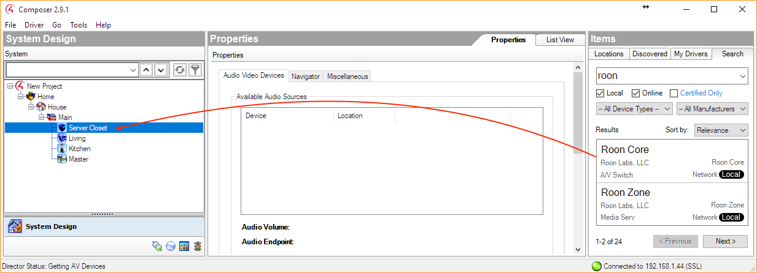

### 

### 

## 2.3 Installing the Roon Zone driver

For each Roon zone that you would like to control using Control4, install a Roon Zone driver in the appropriate room. This is the same as the process for the Core driver above.

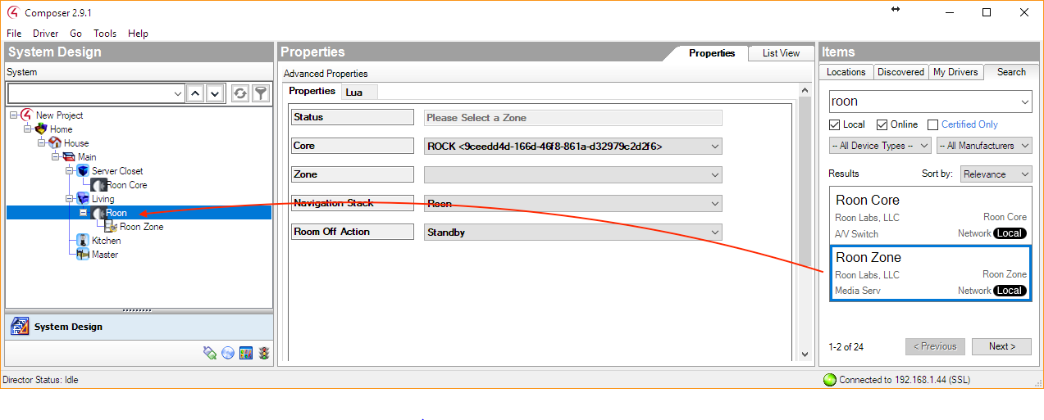

Tip: Rename the driver so that you can recognize it later. This name does not need to match the zone name in Roon.

# 3. Configuration

## 3.1 Roon Core driver configuration

1. Enter the IP Address of the Roon Core, then click the “Set” button

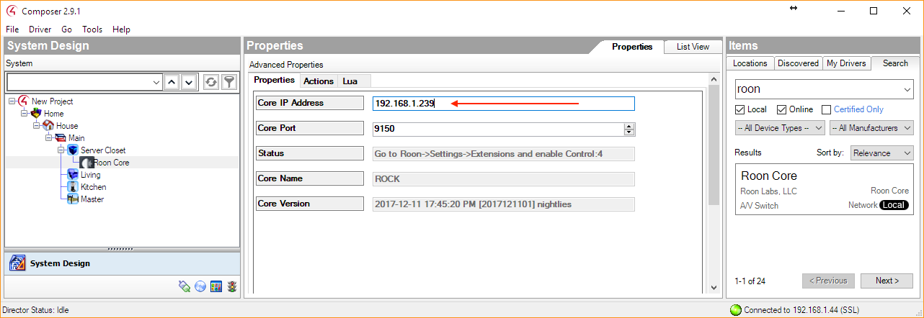

You can find the IP address in Roon at the top of the Settings screen in Roon:

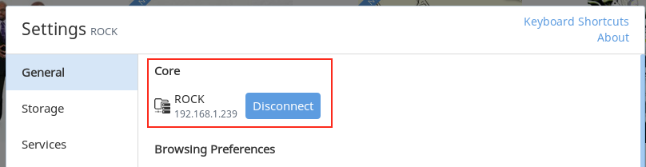

2. In Roon, go into Settings -> Extensions and enable the Control:Four driver.

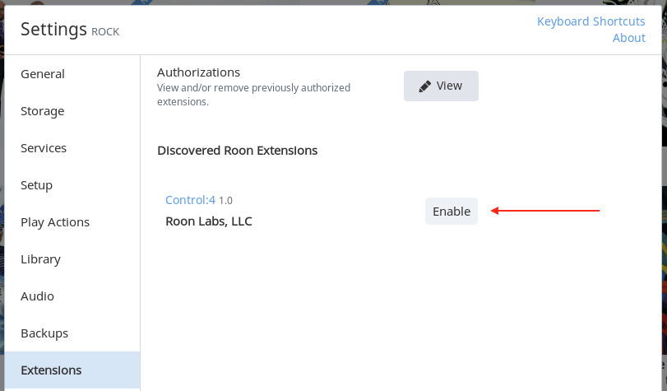

When you click Enable, The Status in Composer should change to “Ready”:

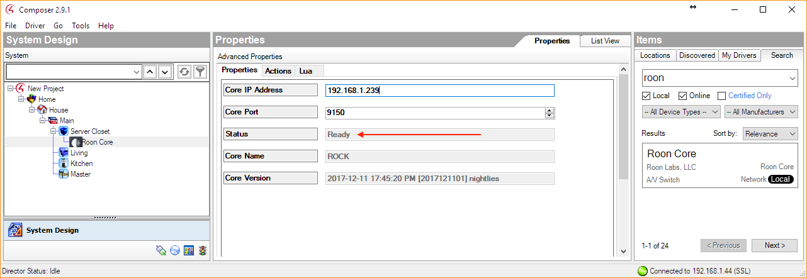

Now the two systems are communicating, and it is possible to configure the Roon Zone drivers.

## 3.2 Roon Zone driver configuration

Each Roon Zone driver needs to be configured separately, set all of these properties for each Roon Zone driver:

1. Select the Roon zone that you wish to control, then click “Set”

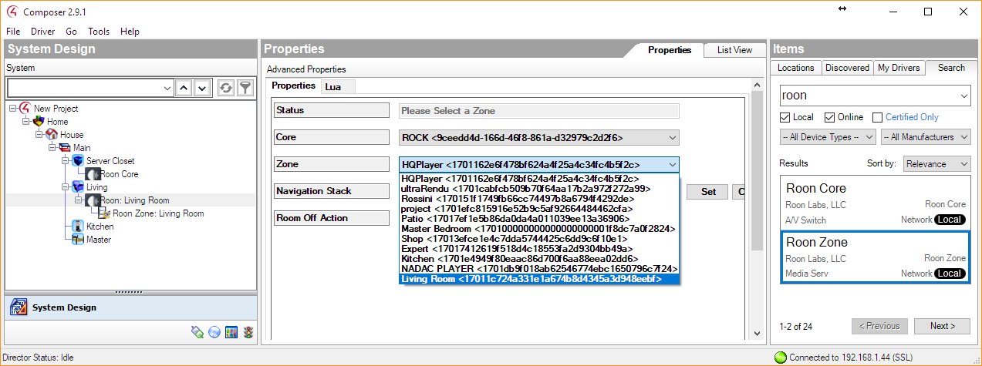

2. Connect the “Audio Endpoint” and “Audio Volume” connections to the room.

### 

3. If configuring multiple zones, you will want to set up the Navigator for each room so that you don’t see duplicate or irrelevant items.

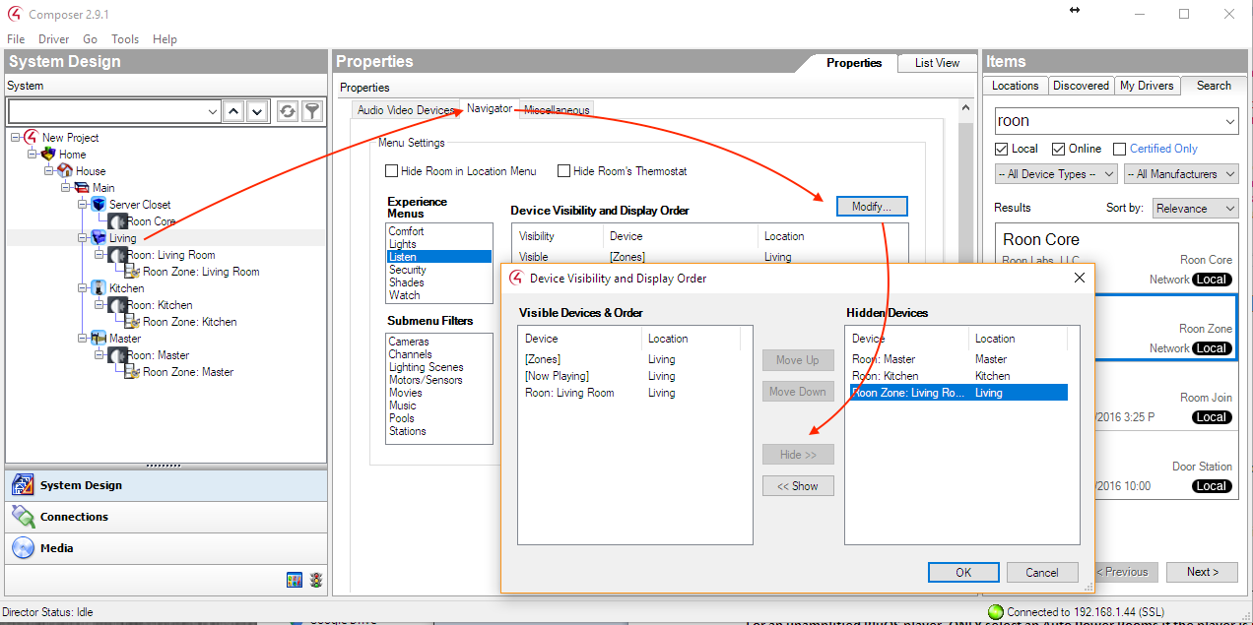

4. Other Roon Zone properties

**Core**

This setting is only for advanced use cases where there are multiple Roon Cores attached to one Control4 system. This is very uncommon.

If you have multiple cores, this setting selects which core the Zone is attached to.

**Room Off Action**

Enables you to choose what happens when the Room is turned off.

Values:

* Standby (Default)
* Stop
* Pause
* Do Nothing

## 3.3 Configure Zone Grouping

Some audio devices can be grouped with others for synchronized playback. This table details the grouping capabilities:

| **Device Type** | **Groups With** |
| --- | --- |
| RAAT (Roon Advanced Audio Transport)  - Roon Ready Devices  - USB Devices  - Built-In Outputs | RAAT (Roon Advanced Audio Transport)  - Roon Ready Devices  - USB Devices  - Built-In Outputs |
| AirPlay | AirPlay |
| Sonos | Sonos |
| Meridian | Meridian |
| Logitech Squeezebox | Logitech Squeezebox |
| KEF LS50 Wireless | N/A |
| Devialet Expert | N/A |
| Signalyst HQPlayer | N/A |

The Roon Core driver exposes five AV Switches, one for each grouping method:

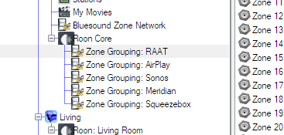

In order for a zone to participate in grouping, it must be connected to an AV switch with only the zones with which it can group. The Roon Core driver knows which devices can group with which other devices, and will connect them for you. Simply use the “Auto Connect Groups” action on the Roon Core driver after selecting an output for each Roon Zone driver in your project.

# 

# 4. Events Programming

## 4.1 Device Specific Commands in Roon Zone Driver

The Roon Zone driver provides the following commands for event programming: Play, Pause, PlayPause, Stop, Skip Forward, Skip Reverse.

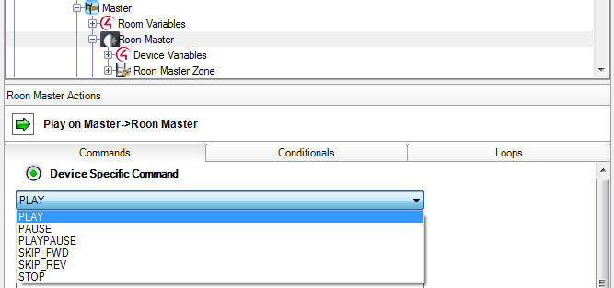

# 

# 

# 5. Support

If you’re having any trouble with Roon and Control:4, please [get in touch with Roon Support](https://community.roonlabs.com/t/im-having-a-problem-with-roon-where-do-i-report-it/2185/5).